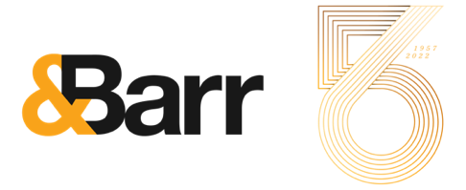
Media Contact:
Shelby Eiger
Shelby.eiger@andbarr.co
407-430-2705

FOR IMMEDIATE RELEASE

Florida’s oldest, largest, independent advertising agency announces major milestone

ORLANDO, Fla. (July 18, 2022) – &Barr, formerly known as Fry, Hammond, Barr, celebrates 65 years of success as Florida’s oldest, largest, independent advertising agency. During nearly seven decades &Barr has not only survived but thrived through the many changes its Orlando home has experienced from pre-Disney to recessions and a pandemic. The locally founded, multi-generational agency has remained independently owned and demonstrated its commitment to helping build a strong regional economy by providing nearly 600 jobs and serving as agency of record (AOR) for hundreds of national and international companies.

Since opening its doors in 1957, &Barr has served a roster of highly acclaimed brands, most notably AAA; Badcock Home Furniture &more; New York Life Investments; Rosen Hotels and Resorts; and Sodexo North America, just to name a few. Unique to most agencies, the company has served its clients up to 30 years, with the YMCA of Central Florida now having been a client for 20 years.

The agency was founded by Chuck Fry, Bob Hammond and Pete Barr, Sr. originally known as Fry, Hammond, Barr until a 2015 rebrand changed its name to &Barr. The ampersand represents partnership and collaboration and a vested interest in each client’s success based on shared goals. Ultimately, &Barr is successful by making its clients successful first.

“Since the beginning, we’ve always prioritized relationships – we treat our clients and our team members like family,” says &Barr President and CEO Pete Barr, Jr. “Along with how we treat people, we are passionate about being the agency of choice for both great brands and talented professionals and providing innovative solutions that truly enhance people’s lives – all proudly from our home of Orlando.”

The agency’s three founders and its current president and CEO have received the AAF Silver Medal Award, recognizing outstanding contributions to advertising and furthering the industry’s standards, creative excellence and responsibility in areas of social concern. &Barr’s talented team – past and present – have been recipients of multiple ADDYs, Tellys, Flagler and HSMAI Adrian Awards, among other individual recognitions. The most recent and notable awards include four gold Graphis awards honoring campaigns for Space Coast Office of Tourism and Badcock Home Furniture &more. In addition to these awards, the agency is one of the original members – still operating today – of American Association of Advertising Agencies (4A’s).

About &Barr
&Barr is a full-service advertising agency providing integrated services, including branding; creative; public relations; account service; social media; and traditional and digital media and analytics. The agency serves a diverse roster of national and international brands, including AAA, Badcock Home Furniture &more, Florida’s Space Coast Office of Tourism, New York Life Investments, Sonny’s BBQ, the YMCA of Central Florida and Sodexo North America, among others. Celebrating its 65th year in business, &Barr’s headquarters is located on Lake Eola in the heart of downtown Orlando, Fla., and the company is proud to be a locally founded, multi-generational, family-owned, independent agency. For more information, visit andbarr.co.

###

